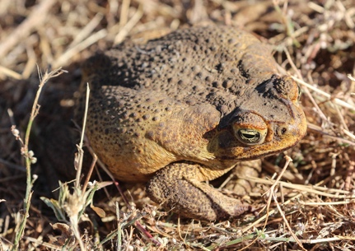
Cane Toad Impact Matrix

In the table below list native Australian species that have been impacted by the cane toad

Name of Animal impacted | Habitat (state, water / land) | How it is affected by the cane toad | How severely has its population been affected?

