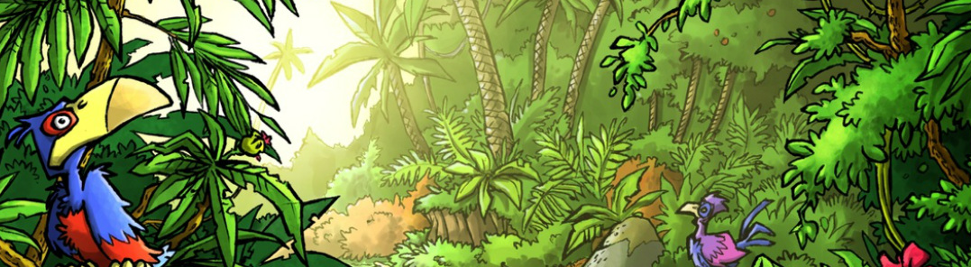
Mini Safari Five

Name:_________________________________________________________________
This mini research safari is designed to get you searching for answers using a range of online search tools. Look at the question carefully to see what kind of information it is asking you to provide.

- What is the oldest known living tree in the world? Where is it found and how old do they think it is?

- What is the difference between a stalactite and a stalagmite?

- What is the main ingredient of hummus?

- What is the main component of blood that is used when you donate blood to the Red Cross?

- How do you say “The echidna and the porcupine are both extremely prickly fellows” in Italian?

- Convert EU $275.20 (Euro) to Egyptian Pounds Rupee.

- What are gites? Who usually uses them?

- What is the difference in height between the Thames River in London at high and low tide?

- What is the largest container ship in the world and how many containers can it hold?

- What is a desalination plant? Which country has the most?

