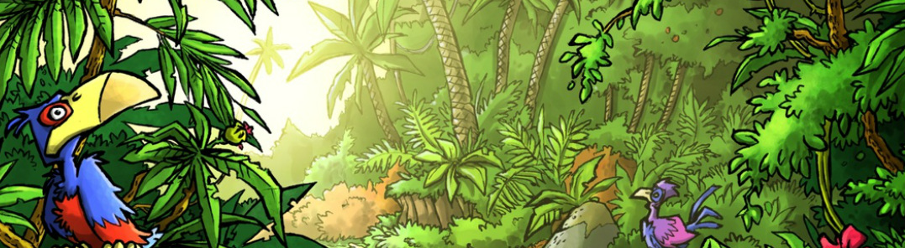

Mini Safari Four

Name:_________________________________________________________________

This mini research safari is designed to get you searching for answers using a range of online search tools. Look at the question carefully to see what kind of information it is asking you to provide.

- Name three volcanoes in the world that are currently active.

- Which animal is more endangered? The polar bear or the sun bear? How do you know?

- How many different kinds of feathers does a male peacock have?

- What is the cerebellum?

- How do you say “The kangaroo and koala are unique to Australia” in Dutch?

- Convert AU $543.25 (Australian) to Indian Rupee.

- Which river is longer and by how much? The Nile of the Ganges?

- What is the difference between a wallaby and a kangaroo?

- Where is the largest dam in the world? How much water does it hold?

- What is the distance between Valencia, Spain and Paris, France?

