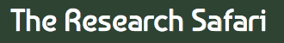
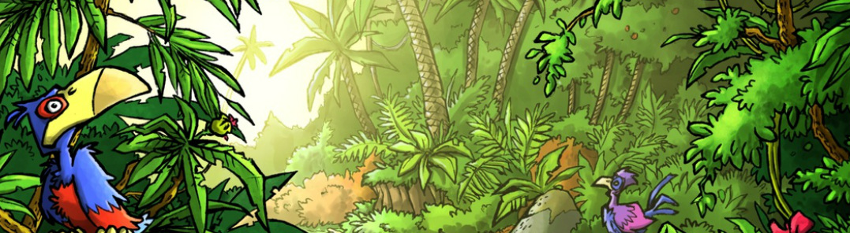

Mini Safari Three

Name:_________________________________________________________________

This mini research safari is designed to get you searching for answers using a range of online search tools. Look at the question carefully to see what kind of information it is asking you to provided.

- What is the Great Garbage Patch and where is it located?

- How many solar eclipses did we have in 2016 and when were they?

- What is the size of the biggest tsunami wave ever recorded? When and where was it?

- Where do you find albumin?

- How do you say “The panda bear is an endangered species” in Icelandic?

- Convert AU $543.25 (Australian) to Scottish Pounds.

- What language is spoken by the most people around the world?

- What is the difference between a sea and an ocean?

- Where is the largest wind turbine farm in the world? How big is it?

- What is the distance between Perth, Western Australia and Adelaide, South Australia?

