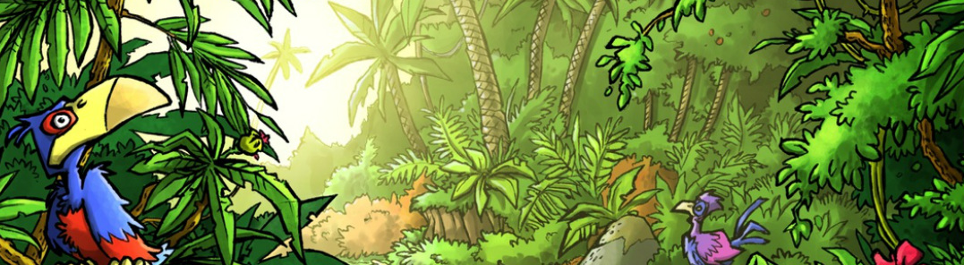

Mini Safari Two

Name:_________________________________________________________________

This mini research safari is designed to get you searching for answers using a range of online search tools. Look at the question carefully to see what kind of information it is asking you to provided.

- Which do you think would be easier to ride? A Dromedary or a Bactrain? Why?

- What does ‘am’ (e.g. 8 am) mean?

- Why is the ice of a glacier so blue?

- What does the term albino mean?

- How do you say “It is going to be very hot today” in German?

- Which countries have hosted the Olympic Games more than three times?

- What currency is used in Egypt?

- What seas are named after colours and where are they found?

- Name four different birds that can’t fly?

- Name five countries that have green and red in their flags

